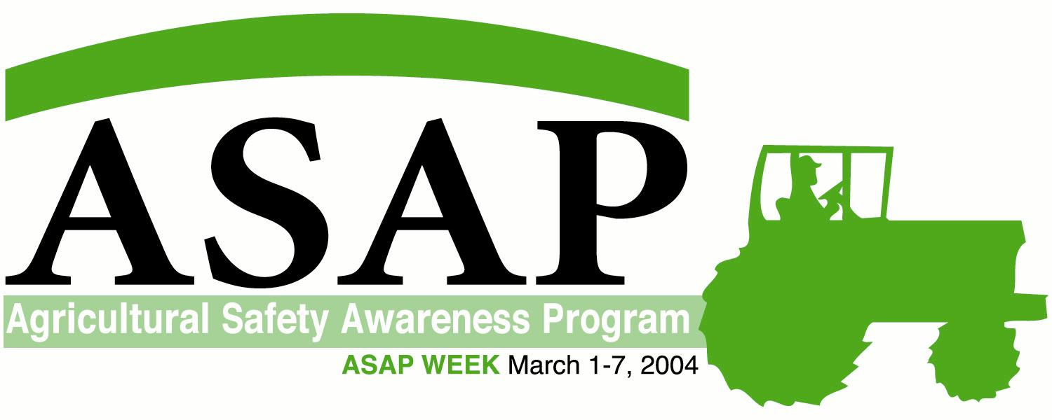

ART: Above

Farm machinery safety and your bottom line
By Liz Foster
Arizona Farm Bureau

Farm and ranch safety affects the bottom line. Employers may or may not have safety plans in place for employees. They may or may not have had a lot of accidents, but when accidents occur it financially affects everyone involved. Premiums on worker’s compensation insurance increase and medical bills and lost time add to the cost of employees. One expense sometimes overlooked is the down time or replacement of damaged equipment. If equipment has to be repaired or replaced it will affect the bottom line. Some employers think safety programs are a waste of employees’ time. How many times has it been said, “I’m not paying them to stand around, I’m paying them to work.” A tailgate safety program or equipment safety check may take fifteen to twenty minutes that may be worth the money spent rather than paying $145,000 for a new tractor after it rolls over.
Thousands of highway accidents involving farm machinery occur each year even when farm equipment is clearly marked with slow moving vehicle (SMV) emblems. Tractors, swathers, cotton pickers and other equipment need to be equipped with hazard warning lights and headlights to provide advanced warning for other drivers sharing the roadways. In our fast paced world, drivers often are speeding, distracted, or impatient and have difficulty anticipating the operational intentions of farm machinery being driven on rural highways.
Farmers and ranchers work long hours when they are trying to finish the harvest season. Accidents can occur when fatigue, stress and racing against Mother Nature are part of the end-of-season rush. Farmers should make sure operators are physically and mentally fit when operating tractors. In addition to stress and fatigue, medication, alcohol and drugs can factor into an unsafe driver. Encourage breaks to refresh the body and mind.
Even in the hot Arizona climate, there are tractors without cabs. These tractors should come with, or have a rollover protective structure (ROPS) and seat belts. More than half of all farm tractors in the U.S. are not equipped with ROPS. ROPS and seatbelts would save approximately 350 lives annually on U.S. farms. Tractor overturns without ROPS account for nearly half of agricultural fatalities.

Safety tips
- While tractors are an essential part of agriculture, there are safety issues to consider when operating them. When dismounting tractors, turn off the engine, remove the key and wait for all moving parts to stop.
- Never attempt to by-pass start a tractor, it may be in gear and drive over the person in front of the wheel.
- Do not take passengers. There is only one seat available on the tractor and that is for the driver.
- Carry out regular safety inspections of equipment and facilities. Make necessary repairs and keep guards and shielding on.
- Develop a safety plan tailored to your operation, your family and your employees. Plans can include a lockout tag-out program for equipment, a fire protection plan, a chemical storage plan, farm safety rules and regulations, emergency field communications and a plan in the event a serious farm injury or death occurs.
- Review and enforce plans with employees and family members.

March 1-7, recognizes the American Farm Bureau Agricultural Safety Awareness Program (ASAP). Farm Bureau encourages you to spend some time discussing farm and ranch safety with employees and family. It could save lives and money in the end.

Liz Foster is the Farm Bureau Government Relations Programs Manager and is responsible for Farm Bureau’s safety program and the Farm Bureau State Fund Safety Dividend Group. For more information on farm safety, contact Foster at (480) 635-3611 or lizfoster@azfb.org.

/tmp/in/input.doc

