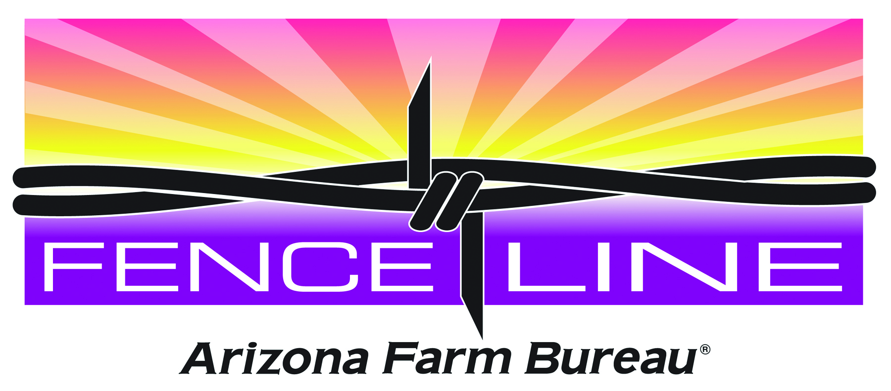 Fence Line, an Agriculturalist Speakers’ Bureau
Learn about Arizona Agriculture from Arizona farmers & ranchers

The Arizona Agriculturalist Speakers’ Bureau is a non-profit program aimed at educating the consumer to buy safe, affordable and locally grown food while recruiting new advocates for agriculture. This is a public outreach effort to create a face-to-face outlet for farmers and ranchers to tell consumers about agriculture and to dispel misconceptions about agriculture and food safety.

Speakers will receive mileage compensation from the organizations that invite them to speak.

Speaker Confirmation Form

 Yes, I am willing to speak to an organization(s):

Name____________________________________ County _________________________
Address__________________________________ City ZIP _______
E-mail _______________________ Phone __________________Cell
Topic (s) Please check all that apply
□ Food Safety □ Agritourism
□ Buying Local □ Animal Care
□ Yuma, the winter salad bowl □ Protecting Your agriculture
□ Ag in the Classroom □ How I grow/produce
□ Misconceptions About Agriculture □ Other

Available to speak: □Monthly □ Four times/year □ Two times/year □ Other
Do you give tours of your operation? □ Yes □ No

 NO, I won’t speak but I will:
□ Use Twitter to tell my story □ Use Facebook to tell my story
□ Use Blogs to tell my story □ Write an article

Questions? Call (480) 635-3609
Please return this form immediately to: Arizona Ag Speakers’ Bureau

Attention: Peggy Jo Goodfellow, 325 S. Higley Rd., Suite 210, Gilbert, AZ 85296

peggyjogoodfellow@azfb.org or fax to 480.635.3781

