**Fabulous Flowers**

**Taken from** [**www.agclassroom.org**](http://www.agclassroom.org)

**Grade Level(s):** K-2

**Estimated Time:** 40 minutes

**Purpose:** The purpose of this lesson is to review the functions of flowers and to help students understand some flowers are edible.

**Materials:**

* Broccoli
* Cauliflower
* Vase
* Vegetable Dip
* Cotton ball spray painted yellow (pollen)
* Straws (bee proboscis)
* Flowers

**Vocabulary:**

**Farm:** a piece of land where crops or animals are raised

**Farmer:** a person who produces food, fiber, or plants, for others to use

**Fruit:** scientifically speaking, the matured ovary of a flower and its contents; some fruits such as squash are called vegetables because they are vegetation that is prepared for the table

**Pollen:** a fine powdery substance, typically yellow, consisting of microscopic grains discharged by the male part of a flower which can fertilize the female ovule in a plant to produce fruit

**Background Agricultural Connections**

This lesson is part of a series called, *Edible Plant Parts.*These lessons allow students and teachers to examine the six basic plant parts—roots, stems, leaves, flowers, fruits, and seeds—in a unique way. Through hands-on activities, students will learn about the different plant parts, as well as how to include fruits and vegetables into their daily meals as part of a healthy diet. Students will also learn about **agriculture** and the people who produce our food. The remaining lessons can be found at the following links:

* 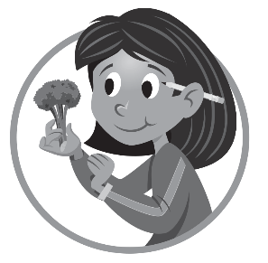[*Why People Need Plants*](http://www.agclassroom.org/teacher/matrix/lessonplan.cfm?lpid=46&search_term_lp=why%20people%20need%20plants)
* *Dig 'Em Up*
* [*Snappy Stems*](http://www.agclassroom.org/teacher/matrix/lessonplan.cfm?lpid=321&search_term_lp=snappy%20stems)
* [*Luscious Leaves*](http://www.agclassroom.org/teacher/matrix/lessonplan.cfm?lpid=47&search_term_lp=Luscious%20leaves)
* [*Fabulous Flowers*](http://www.agclassroom.org/teacher/matrix/lessonplan.cfm?lpid=93&search_term_lp=fabulous%20flowers)
* [*Freshest Fruits*](http://www.agclassroom.org/teacher/matrix/lessonplan.cfm?lpid=322&search_term_lp=freshest)
* [*Supreme Seeds*](http://www.agclassroom.org/teacher/matrix/lessonplan.cfm?lpid=323&search_term_lp=supreme%20seeds)
* [*Edible Plant Game*](http://www.agclassroom.org/teacher/matrix/resources.cfm?rid=115&search_term_cr=edible%20plant%20game)
* [*Eat 'Em Up*](http://www.agclassroom.org/teacher/matrix/lessonplan.cfm?lpid=324&search_term_lp=eat)

**Flowers** are the reproductive parts of plants. Some flowers have colorful petals and fragrances that attract pollinators such as bees, flies, butterflies, and moths. These insects transfer **pollen** from flower to flower. Most flowers produce seeds, which develop in the ovary of the fertilized flower. When planted in the proper environment seeds grow into new plants and the ripened ovary becomes the**fruit**.

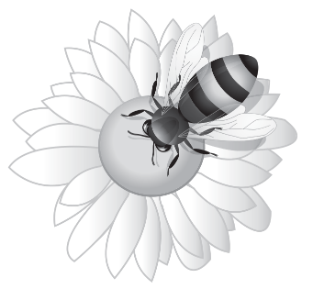Flowers of some plants are edible, including broccoli, cauliflower, and artichokes. Broccoli and cauliflower flowers are called “heads” and are usually eaten along with their stems, whereas artichokes, which are actually the buds of flowers, are eaten without the stems. Other flowers such as zucchini and orchid flowers, are considered a delicacy in some parts of the world.

Students should be warned that some flowers are poisonous and they should never eat anything they are unsure of, unless it is approved by a responsible adult.

**Interest Approach**

1. Ask your students to describe characteristics of flowers and make a list on the board.
2. Ask students to list places where they see flowers. Students will likely recall seeing flowers in gardens and flower beds around their home, neighborhood, or at the school.
3. Ask students if they have ever seen a flower on their dinner plate. Inform the students that they will be learning about flowers and how they are important to having our food supply.

**Procedures**

1. After brainstorming characteristics of the flower for the motivator, review and discuss the reproductive functions of flowers with the class. The flower attracts pollinators, such as insects and birds, and makes seeds that will grow into new plants.
2. Ask students if they know what a pollinator is. Explain that pollinators are animals that move pollen from the male part of flowers to the female part of flowers. Most plants require pollination to reproduce. Ask students if they can think of any examples of pollinators.
3. Play the *Bee Pollination Game* outside. Half the class will play the role of a bee and half will play the role of a flower. The “flowers” will each stand outside holding a flower (daisy, rose, or another flower that is available) and a yellow cotton ball for pollen. “Bees” will each have a half of a straw for their proboscis. Bees will also have a cotton ball, which represents pollen that stuck to them as they were visiting flowers. Explain that bees must fly around the garden looking for flowers so they can drink their nectar. Bees will go from flower to flower and pretend to drink nectar with their straw proboscis. At each flower “bees” and “flowers” are to trade “pollen” (cotton balls). Explain that as bees are busy gathering flower nectar for food, the pollen accidentally gets stuck on their legs or fuzzy body and this is how they end up carrying pollen from one flower to another, thus pollinating the flowers so they can develop fruit and seeds. At the end of one round, have students switch roles so everyone gets a chance to be the flower and the bee.
4. Arrange broccoli, artichokes, and cauliflower in a vase of water. Tell your students that you received a beautiful bouquet of flowers. Show them your bouquet. Discuss that broccoli, cauliflower, and artichokes are flowers that people eat.
5. Draw the life cycle of broccoli on the board. Begin with the seed, which grows into a plant with leaves, then show the buds on the head of a broccoli flower, then the flowering broccoli plant, and then back to the seed. Show students the stage at which we pick the broccoli to eat, just before it flowers.
6. Cut the broccoli and cauliflower into bite-sized pieces. Distribute them with vegetable dip and have the students taste the flowers.

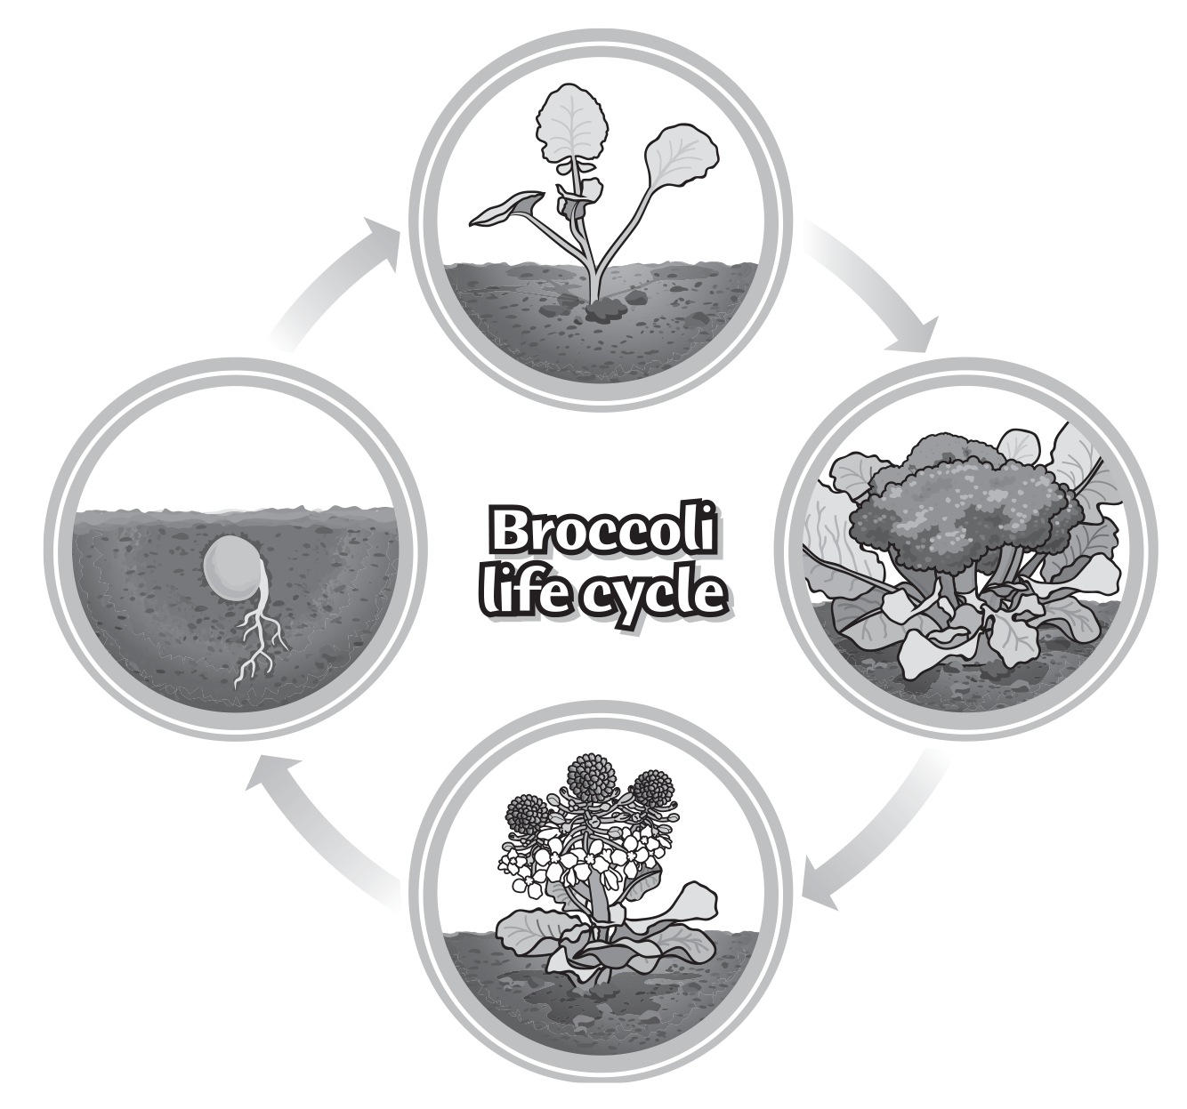

**Concept Elaboration and Evaluation**

After conducting this activity, review and summarize the following key points:

* Flowers are the reproductive parts of plants.
* Flowers attract pollinators such as bees and other insects.
* Flowers of certain plants are edible.

**Enriching Activities**

* Go to your local supermarket or nursery and obtain flowers that are no longer sellable. Have the students dissect the flowers and identify the parts.
* Have students research pollinators and invite a beekeeper into your classroom. Contact your local county Farm Bureau for possible guest speakers.
* Place the stem of a whole head of broccoli in a vase of water to see if the flowers will bloom.
* Invite a flower farmer into your classroom. Have the farmer discuss the flower operation and bring several examples of flowers for display. Contact your local county Farm Bureau for possible guest speakers.
* Have students make prints with an artichoke. Cut the artichoke in half lengthwise, dip the artichoke in paint, and then press it on construction paper.

**Suggested Companion Resources**

* [How Do Flowers Grow?](http://www.agclassroom.org/teacher/matrix/resources.cfm?rid=246) (Book)
* [How Flowers Grow](http://www.agclassroom.org/teacher/matrix/resources.cfm?rid=257) (Book)
* [Sunflower House](http://www.agclassroom.org/teacher/matrix/resources.cfm?rid=209) (Book)
* [The Fruits We Eat](http://www.agclassroom.org/teacher/matrix/resources.cfm?rid=203) (Book)
* [The Reason for a Flower](http://www.agclassroom.org/teacher/matrix/resources.cfm?rid=133) (Book)
* [Jr. Sprout - Gardening](http://www.agclassroom.org/teacher/matrix/resources.cfm?rid=212) (Booklets & Readers)
* [The Buzz About Bees](http://www.agclassroom.org/teacher/matrix/resources.cfm?rid=490) (Website)

**Sources/Credits**

***This lesson update was funded by a grant from the Network for a Healthy California.***  
Executive Director: Judy Culbertson  
Illustrator: Erik Davison  
Layout & Design: Nina Danner  
Copy Editor: Leah Rosasco

***Author(s)***Shaney Emerson and Michelle Risso

***Organization Affiliation***California Foundation for Agriculture in the Classroom

