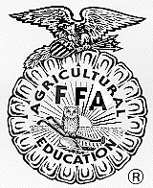
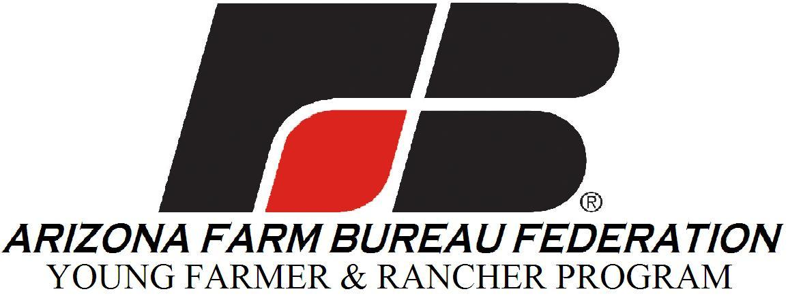

THE ARIZONA FFA DISCUSSION MEET
Sponsored by the Arizona Farm Bureau
Young Farmer & Rancher Committee

2023 State FFA Discussion Meet Registration Form

Contestant’s Name:

Phonetic Pronunciation:

Address:

Phone:

Email:

Age: Date of Birth:

FFA Chapter:

The competition will be held June 9, 2023 at the State FFA Leadership Conference. Check in will begin at 8:30 AM. Room assignments and the first question will be given at that time of check in. First round will take place on June 9 starting at 9 AM. Winners of the FFA DM will be announced at the SLC General session Friday Evening.
Arizona Farm Bureau Federation reserves the right to use your photo and/or any video footage for use in promoting Farm Bureau. The photos and/or video footage of undersigned contestant may also be available to sponsors of Farm Bureau events.

Email applications to : Christy Davis
Arizona Farm Bureau Federation
325 S Higley Rd. Suite 210
Gilbert, AZ 85296-4320
Phone 480-635-3615
christydavis@azfb.org

Discussion Meet Application deadline is May 22, 2022

